Your toddler’s sleep at 2 - 3 Years
Sleep is not under our control and cannot be forced
Your sleeping toddler
At this stage your toddler may sleep from 9-12 hours at night with 1 nap of approximately 1-2 hours during the day. They may also start slowly reducing the frequency of their nap or cutting it out completely.
Your child’s circadian rhythm (sleep-wake cycle) is well established and their sleep patterns are fairly comparable to an adult, but psychologically, things are very different. At this age, they are desperately crying out for more control over their life.

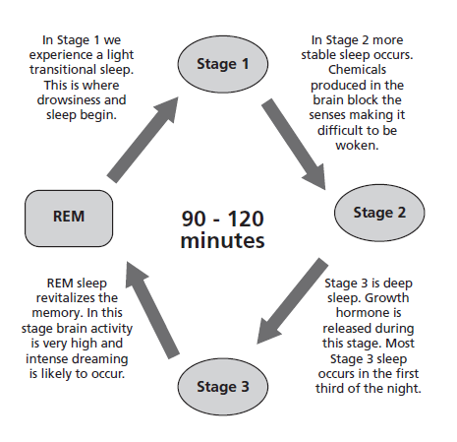

What can affect sleep?
- Sleep at this age is linked to behaviour Changes to family circumstances e.g., starting nursery, potty training, holidays, transition to a bed and a new baby in the family can all cause sleep regressions.
- Many toddlers face common sleep challenges including resisting going to bed, early waking, night-time awakenings, fears, and nightmares.
- A toddler’s drive for independence and an increase in their motor, cognitive and social abilities can all interfere with their sleep In addition, their ability to get out of bed, separation anxiety, the need for independence and the development of their imagination can lead to sleep challenges.
- Daytime sleepiness and challenging behaviour may signal poor sleep patterns For example, moving to a ‘big bed’ when your toddler still wants to be ‘your baby’ may cause initial confusion and resistance.
- Ailments such coughs, colds, nasal congestion, eczema, teething, and chicken pox may impact on your child’s comfort levels during the night, affecting their ability to settle. Treating these ailments will help your toddler settle back into their usual sleep pattern.
Your toddler’s development
- At this age, your toddler may start to copy adults and peers. They enjoy pretending and role play, and repeating words heard in conversations and books.
- Their understanding and comprehension are developing which encourages negotiations, but your toddler is now also becoming more physically and emotionally independent. They can appear bossy and can exhibit defiant behaviour and have tantrums.
- Your toddler may begin to show an interest in potty training. This is best being child led and should not be rushed.

Ideas to support you and your toddler
- Connect with your toddler They need to feel your unconditional love. Consider the way you communicate with your toddler (remembering your child’s age and comprehension levels). Respond calmly and lovingly, especially at night. Make them feel happy and secure in their sleeping environment.
- Bedtime routine is important Including your toddler in this by giving encouraging reminders of the next stage in the routine to help towards a calm and relaxed environment.
- Respect your toddler’s choice of items for their bedroom Black out blinds may help in the summer months. Keep lighting to a minimum at night and naturally lit in the daytime. If your toddler tends to fall asleep with a particular comfort in place, ensure it can be maintained all night, for example a night light (red light is said to be more relaxing) or having the door partly open.
- Temperature Keep the temperature in the bedroom at a comfortable temperature, ideally 16-18 degrees Celsius. Ensure their bed is comfortable; try lying on it yourself.
- Always end the day with praise and happy thoughts Bear this in mind when choosing their bedtime story. Avoid screen activities leading up to bedtime as it prevents melatonin production (the sleep hormone). Fine motor skill activities such as jigsaws, colouring and playdough are more calming and aid relaxation. A bath may help too.
- Drinks Certain drinks near to bedtime can over stimulate the bladder e.g., blackcurrant juice, caffeine and hot chocolate and results in in disturbed sleep. More soothing drinks include warm milk or water. It is normal for children to be in nappies at night-time at this age.
- Comfort Your toddler may have a special comfort object for bedtime, a spare one may be helpful in case it gets lost or needs a wash.
- Reassurance If your toddler needs reassurance by your presence when settling to sleep at night, consider staying in the bedroom for a while. Make yourself comfortable and engage yourself in a relaxing activity, read or put your earphones in and listen to some music. Your presence alone may be all that is needed. You may wish to gradually retreat or slowly reduce the amount of time that you are in their room.
- Alleviating distress If your child is becoming distressed during this process, you could try staying in the bedroom longer, retreating slower and offering more comfort. It will take time, but this is okay and will resolve.
As a service we do not recommend any sleep modification/training techniques that involve leaving your child to cry, such as controlled crying, pick up/put down. Recent evidence highlights the importance of responding to all their needs responsively, to achieve optimum health and emotional wellbeing for your child.
For further support or information please contact your Children’s Health Team on 01522 843000.
For more information on how children sleep please visit The Sleep Charity at Home - The Sleep Charity

